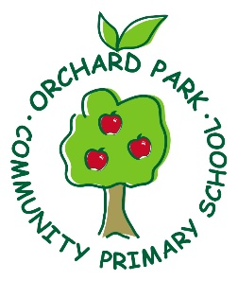

ORCHARD PARK COMMUNITY PRIMARY SCHOOL
POLICY INFORMATION

Privacy Notice – Orchard Park School Job Applicants

Our Mission Statement

A place where children are empowered to reach their full potential, with the highest possible aspirations and passion for learning. With values and respect, our children are confident to move from our nurturing environment to explore and succeed in the wider world.

